Sales Performance Analysis

# Introduction

This report analyses sales performance data for 2023 across product categories, sales channels, regions, and time periods. The dataset includes transaction-level details, regional summaries, and category-specific revenue breakdowns. The goal is to identify key trends, uncover growth opportunities, and provide actionable recommendations to optimize sales strategy.

**Performance Dashboard**

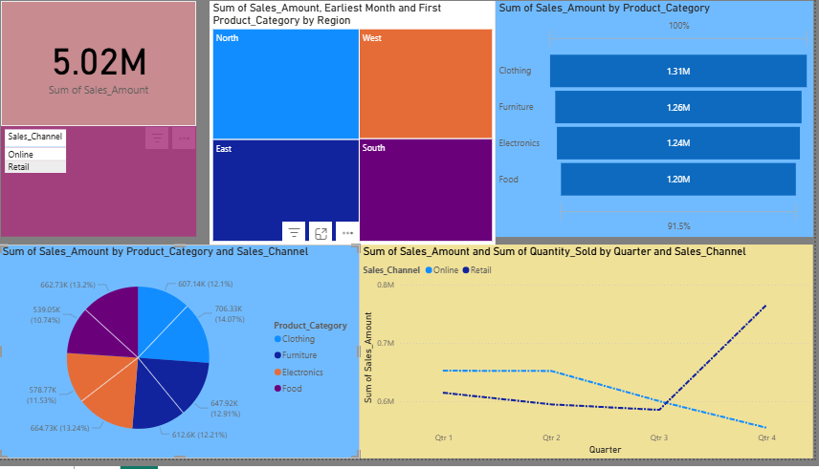

Findings

* Furniture dominates: Highest revenue ($394,983), followed by Clothing ($372,977).
* Food underperforms: Lowest sales ($258,986),
* Online channel excels: Higher transaction frequency and peak daily sales ($19,957).
* Peaks in Q4: Highest single-day sale ($19,958 on Oct 16).
* North leads: Highest total sales ($1.37M), while South lags ($1.15M).
* Q1 & Q4 drive sales: January (Online) and October/December (Retail) are peak months.
* Mid-year: April (Online) and June (Retail) show the lowest activity.

## Sales by Product Category

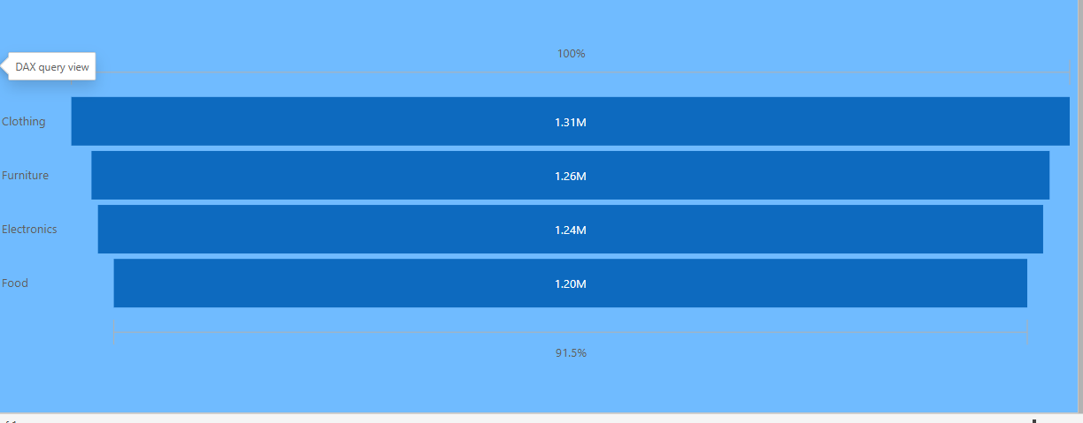

* **Description**: The **Clothing** category has the highest sales (set as 100%).
* The **Food** category has the lowest, with about **91.5%** of Clothing’s sales.

### Sales by Quarterly

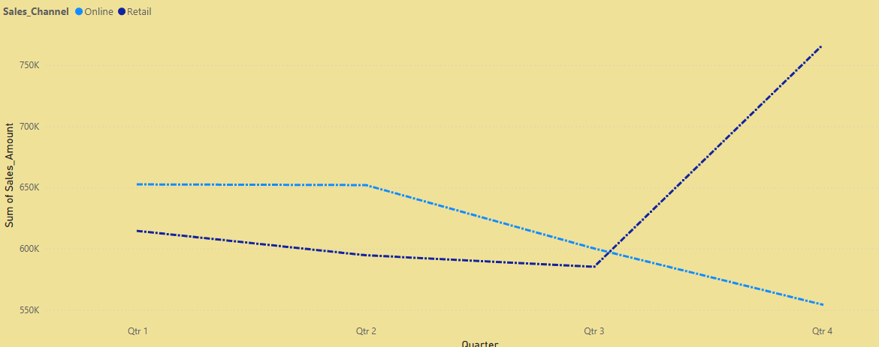

* **Description**: The **Retail** sales begin at a mid-level, gradually decline over the quarters, reaching the lowest point in Q4.
* The **Sales Channel** (black solid line) starts low but remains relatively flat until Q3, then sharply rises in Q4, surpassing the other channels.

#### Sales by Channel

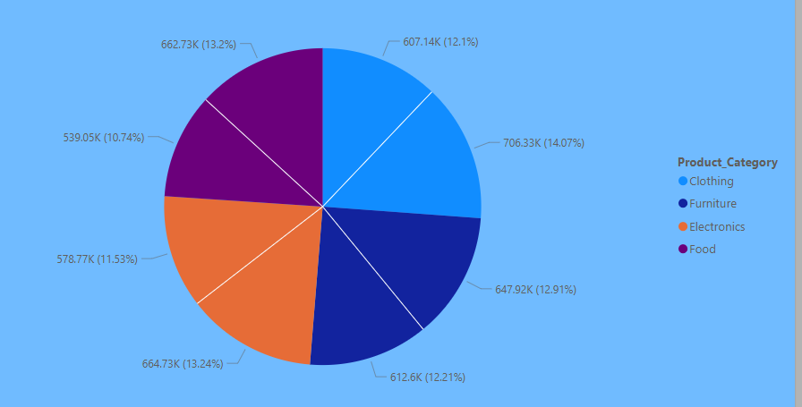

* **Description**: **Clothing** leads with the highest sales of **1.31 million.**
* **Furniture** follows with **1.26 million**.
* **Electronics** ranks third with **1.24 million**.
* **Food** has the lowest sales, at **1.20 million**, which is **91.5%** of the top category.

Recommondations

* Increase overall revenue by 15-20% through category/channel optimization.
* Balance regional performance, reducing the North-South gap by 25%.
* Turn mid-year slumps into growth opportunities (+10% sales in Q2/Q3).

Thank You